Analysis: Storms and other severe weather events in public health and economic problems for communities and municipalities in US Storms.

DavidC.

31/08/2019

Github repository for the Course: [Reproducible Research](https://github.com/dcastellanogargiulo/coursera-reproducible-research-peer-assessment2-master)

1: Synopsis

The goal of the assignment is to explore the U.S. National Oceanic and Atmospheric Administration’s (NOAA) Storm Database and explore the effects of severe weather events on both population and economy. The events in the database start in the year 1950 and end in November 2011.

The following analysis investigates which types of severe weather events are most harmful on:

1. Health (Injuries and Fatalities)
2. Property damage and crops (Economic Consequences)

Source of information on the data: [Storm Data Documentation](https://d396qusza40orc.cloudfront.net/repdata%2Fpeer2_doc%2Fpd01016005curr.pdf)

2: Environment Preparation

2.1: Setup libs and download data

*# Install needed libs if needed*

*#install.packages("ggplot2")*

*#install.packages("data.table")*

*#library("knitr")*

*# Load the library's into R Studio memory.*

setwd("~/coursera/data")

**library**("data.table")

**library**("ggplot2")

**library**(knitr)

*# Download and read the CSV files into stromDateFrame.*

sourceFileUrl <- "https://d396qusza40orc.cloudfront.net/repdata%2Fdata%2FStormData.csv.bz2"

download.file(sourceFileUrl, destfile = paste0(getwd(), './repdata_data_StormData.csv.bz2'))

## Warning in download.file(sourceFileUrl, destfile =

## paste0(getwd(), "./repdata_data_StormData.csv.bz2")): URL https://

## d396qusza40orc.cloudfront.net/repdata%2Fdata%2FStormData.csv.bz2:

## cannot open destfile '/Users/davidecastellano/coursera/data./

## repdata_data_StormData.csv.bz2', reason 'No such file or directory'

## Warning in download.file(sourceFileUrl, destfile = paste0(getwd(), "./

## repdata_data_StormData.csv.bz2")): download had nonzero exit status

stromDateFrame <- read.csv("./repdata_data_StormData.csv.bz2")

*# Converting data.frame to data.table*

stromDateTable <- as.data.table(stromDateFrame)

2.2: Data Structure Verification (optional).

*# Display list of column's for the data.table (stromDateTable).*

colnames(stromDateTable)

## [1] "STATE__" "BGN_DATE" "BGN_TIME" "TIME_ZONE" "COUNTY"

## [6] "COUNTYNAME" "STATE" "EVTYPE" "BGN_RANGE" "BGN_AZI"

## [11] "BGN_LOCATI" "END_DATE" "END_TIME" "COUNTY_END" "COUNTYENDN"

## [16] "END_RANGE" "END_AZI" "END_LOCATI" "LENGTH" "WIDTH"

## [21] "F" "MAG" "FATALITIES" "INJURIES" "PROPDMG"

## [26] "PROPDMGEXP" "CROPDMG" "CROPDMGEXP" "WFO" "STATEOFFIC"

## [31] "ZONENAMES" "LATITUDE" "LONGITUDE" "LATITUDE_E" "LONGITUDE_"

## [36] "REMARKS" "REFNUM"

2.3: Data Wrangling (cleaning)

Subset the dataset on the parameters of interest. Basically, we remove the columns we don’t need for clarity.

*# Finding columns to remove*

cols_to_Remove <- colnames(stromDateTable[, !c("EVTYPE"

, "FATALITIES"

, "INJURIES"

, "PROPDMG"

, "PROPDMGEXP"

, "CROPDMG"

, "CROPDMGEXP")])

*# Removing columns*

stromDateTable[, c(cols_to_Remove) := NULL]

*# Only use data where fatalities or injuries occurred.*

stromDateTable <- stromDateTable[(EVTYPE != "?" &

(INJURIES > 0 | FATALITIES > 0 | PROPDMG > 0 | CROPDMG > 0)), c("EVTYPE"

, "FATALITIES"

, "INJURIES"

, "PROPDMG"

, "PROPDMGEXP"

, "CROPDMG"

, "CROPDMGEXP") ]

2.4: Data Wrangling (translation)

Making the PROPDMGEXP and CROPDMGEXP columns cleaner so they can be used to calculate property and crop cost.

*# Change all damage exponents to uppercase.*

cols <- c("PROPDMGEXP", "CROPDMGEXP")

stromDateTable[, (cols) := c(lapply(.SD, toupper)), .SDcols = cols]

*# Map property damage alphanumeric exponents to numeric values.*

propDmgKey <- c("\"\"" = 10^0,

"-" = 10^0,

"+" = 10^0,

"0" = 10^0,

"1" = 10^1,

"2" = 10^2,

"3" = 10^3,

"4" = 10^4,

"5" = 10^5,

"6" = 10^6,

"7" = 10^7,

"8" = 10^8,

"9" = 10^9,

"H" = 10^2,

"K" = 10^3,

"M" = 10^6,

"B" = 10^9)

*# Map crop damage alphanumeric exponents to numeric values*

cropDmgKey <- c("\"\"" = 10^0,

"?" = 10^0,

"0" = 10^0,

"K" = 10^3,

"M" = 10^6,

"B" = 10^9)

stromDateTable[, PROPDMGEXP := propDmgKey[as.character(stromDateTable[, PROPDMGEXP])]]

stromDateTable[is.na(PROPDMGEXP), PROPDMGEXP := 10^0 ]

stromDateTable[, CROPDMGEXP := cropDmgKey[as.character(stromDateTable[, CROPDMGEXP])] ]

stromDateTable[is.na(CROPDMGEXP), CROPDMGEXP := 10^0 ]

stromDateTable <- stromDateTable[, .(EVTYPE, FATALITIES, INJURIES, PROPDMG, PROPDMGEXP, propCost = PROPDMG * PROPDMGEXP, CROPDMG, CROPDMGEXP, cropCost = CROPDMG * CROPDMGEXP)]

3: Data Processing and Verification

3.1: Table: Total Property and Crop Cost.

totalCostDataTable <- stromDateTable[, .(propCost = sum(propCost), cropCost = sum(cropCost), Total_Cost = sum(propCost) + sum(cropCost)), by = .(EVTYPE)]

totalCostDataTable <- totalCostDataTable[order(-Total_Cost), ]

totalCostDataTable <- totalCostDataTable[1:10, ]

head(totalCostDataTable, 5)

## EVTYPE propCost cropCost Total_Cost

## 1: FLOOD 144657709807 5661968450 150319678257

## 2: HURRICANE/TYPHOON 69305840000 2607872800 71913712800

## 3: TORNADO 56947380676 414953270 57362333946

## 4: STORM SURGE 43323536000 5000 43323541000

## 5: HAIL 15735267513 3025954473 18761221986

3.2: Table: Total Fatalities and Injuries.

totalInjuriesDataTable <- stromDateTable[, .(FATALITIES = sum(FATALITIES), INJURIES = sum(INJURIES), totals = sum(FATALITIES) + sum(INJURIES)), by = .(EVTYPE)]

totalInjuriesDataTable <- totalInjuriesDataTable[order(-FATALITIES), ]

totalInjuriesDataTable <- totalInjuriesDataTable[1:10, ]

head(totalInjuriesDataTable, 5)

## EVTYPE FATALITIES INJURIES totals

## 1: TORNADO 5633 91346 96979

## 2: EXCESSIVE HEAT 1903 6525 8428

## 3: FLASH FLOOD 978 1777 2755

## 4: HEAT 937 2100 3037

## 5: LIGHTNING 816 5230 6046

4: Results

4.1: Events that are Most Harmful to Population Health

4.1.1: Table: Top 10 US Killers

Melting data.table so that it is easier to put in bar graph format

bad_stuff <- melt(totalInjuriesDataTable, id.vars="EVTYPE", variable.name = "bad_thing")

head(bad_stuff, 5)

## EVTYPE bad_thing value

## 1: TORNADO FATALITIES 5633

## 2: EXCESSIVE HEAT FATALITIES 1903

## 3: FLASH FLOOD FATALITIES 978

## 4: HEAT FATALITIES 937

## 5: LIGHTNING FATALITIES 816

4.1.1: Chart: Top 10 US Killers

*# Create chart*

healthChart <- ggplot(bad_stuff, aes(x = reorder(EVTYPE, -value), y = value))

*# Plot data as bar chart*

healthChart = healthChart + geom_bar(stat = "identity", aes(fill = bad_thing), position = "dodge")

*# Format y-axis scale and set y-axis label*

healthChart = healthChart + ylab("Frequency Count")

*# Set x-axis label*

healthChart = healthChart + xlab("Event Type")

*# Rotate x-axis tick labels*

healthChart = healthChart + theme(axis.text.x = element_text(angle = 45, hjust = 1))

*# Set chart title and center it*

healthChart = healthChart + ggtitle("Top 10 US Killers") + theme(plot.title = element_text(hjust = 0.5))

healthChart

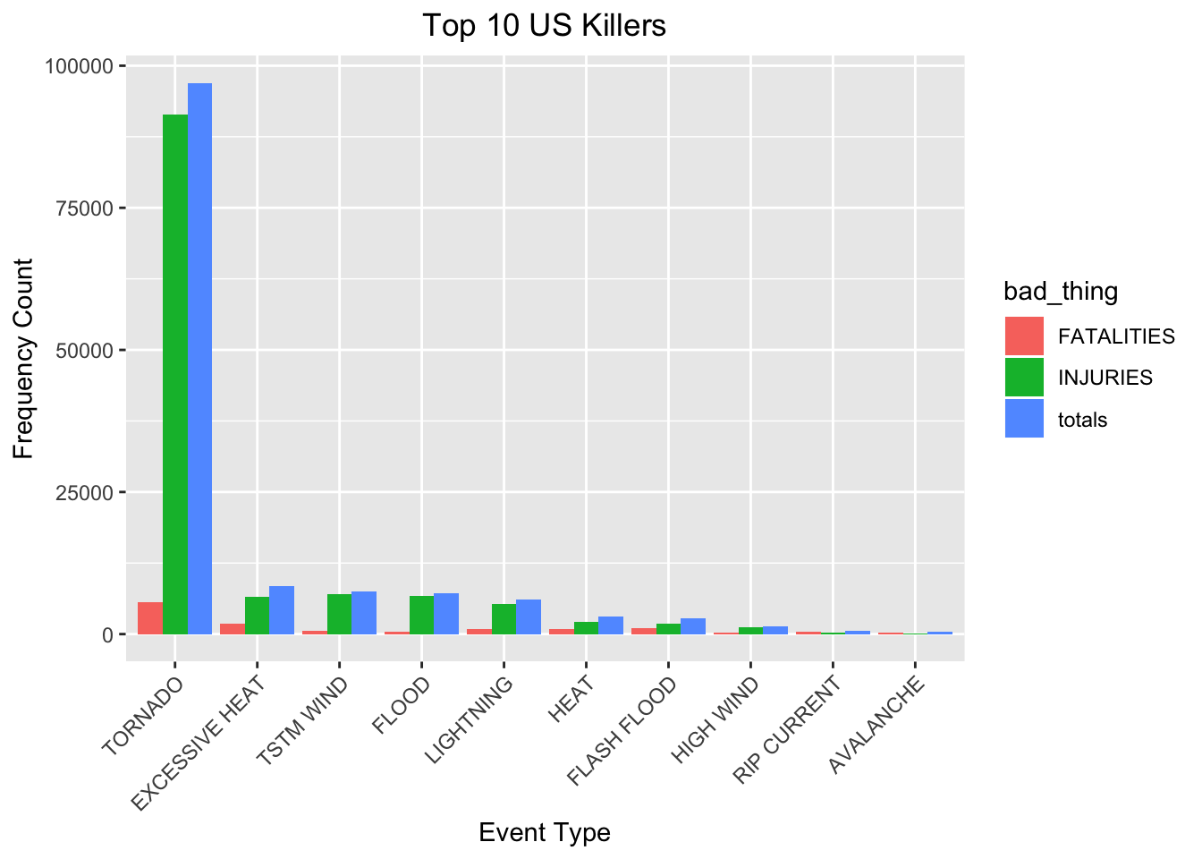

4.2: Events that have the Greatest Economic Consequences

4.2.1: Table: Top 10 US Storm Events causing Economic Consequences

Melting data.table so that it is easier to put in bar graph format

econ_consequences <- melt(totalCostDataTable, id.vars="EVTYPE", variable.name = "Damage_Type")

head(econ_consequences, 5)

## EVTYPE Damage_Type value

## 1: FLOOD propCost 144657709807

## 2: HURRICANE/TYPHOON propCost 69305840000

## 3: TORNADO propCost 56947380676

## 4: STORM SURGE propCost 43323536000

## 5: HAIL propCost 15735267513

4.2.2: Chart: Top 10 US Storm Events causing Economic Consequences

*# Create chart*

econChart <- ggplot(econ_consequences, aes(x = reorder(EVTYPE, -value), y = value))

*# Plot data as bar chart*

econChart = econChart + geom_bar(stat = "identity", aes(fill = Damage_Type), position = "dodge")

*# Format y-axis scale and set y-axis label*

econChart = econChart + ylab("Cost (dollars)")

*# Set x-axis label*

econChart = econChart + xlab("Event Type")

*# Rotate x-axis tick labels*

econChart = econChart + theme(axis.text.x = element_text(angle = 45, hjust = 1))

*# Set chart title and center it*

econChart = econChart + ggtitle("Top 10 US Storm Events causing Economic Consequences") + theme(plot.title = element_text(hjust = 0.5))

econChart

